Admin Manual – You Might Dig

Contents

Test Form 2

Admin Settings 2

Gather 2

Manage genres 3

Blacklisted Genres 3

Hidden genres 3

Manage characteristics 3

# Test Form

Click the bellow link to open the Testing Form. In form you will answer a series of questions that will highlight fixes or improvements we can make to the site.

[Form](https://docs.google.com/forms/d/1nYTPpTYM3ihr5zlL484RYMEdrhAN3n1vR2KpzeBTc9Q/edit)

# Admin Settings

To enter the administrator settings, click your login, then from the dropdown select “Admin”. You will then enter the default admin overview page, where you can see the overview of games, users, genres, characteristics and ratings.

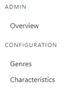

On the left-hand side of the page, there are three pages that you can navigate to. The default overview page, Genres management and Characteristics management. To change pages simply click on the text.

# Gather

On the default overview page, there is an input box that allows you to manually set the max number of games that the system will gather. Simply enter a number and click the Gather button.



# Manage genres

To manage the genres, select the Genres page from the navigation bar on the left-hand side of the screen.

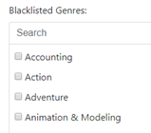

# Blacklisted Genres

Once on the Genres page you can tick each box for each genres you wish not to be gathered.

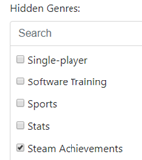

# Hidden genres

Under the black listed genres there is the same setup to manage the hidden genres. Tick a box next to a genre you wish to be gathered, but a user not to be able to view.

# Manage characteristics

Select the characteristics option from the left-hand side menu bar. This page will allow you to assign the different rateable values a genre will have. E.g. the “Racing” genre might need to be rated for “Realism”, whereas a “RPG” does not need to be rated for realism as it would be fictional.

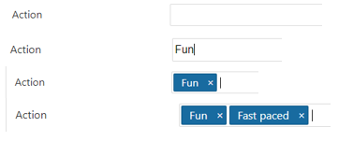To give a Genre a characteristic, click the text box next to the genre e.g. Action. Then type a characteristic you want to represent that genre e.g. Fun. Then hit enter to confirm. To remove a genre hit the small cross next to the characteristic. To add multiple just repeat the process, typing the next on after the last.